Assignment 3 (v2)
Student Id : 202412048
Name : Harsh HemalKumar Mehta

Q1. Create a trigger on Table of your choice to check if the Primary key ID already exists or not , before inserting a new record. & Send a custom reply instead of an error message.
Ans)
Function:
CREATE OR REPLACE FUNCTION check_user_id()
RETURNS TRIGGER
LANGUAGE plpgsql
AS $BODY$
BEGIN
IF EXISTS (SELECT 1 FROM "EC_DB".users WHERE user_id = NEW.user_id) THEN
RAISE EXCEPTION User ID already exists. Please choose a different ID.';
END IF;
RETURN NEW;
END;
$BODY$;
Trigger:
CREATE OR REPLACE TRIGGER trigger_q1
BEFORE INSERT ON "EC_DB".users
FOR EACH ROW
EXECUTE FUNCTION check_user_id();
TestCase:
insert into "EC_DB".users values (1,'tmp','tmp@gamil.com','asdfg','tmp','tmp','tmp');
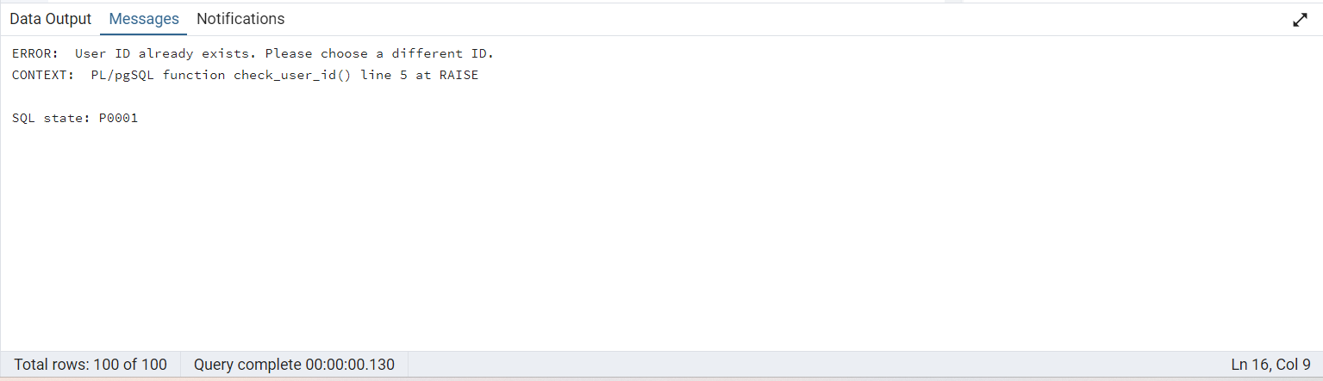
Q2. Create a trigger on the Table of your choice to check if the Foreign key ID already exists or not before inserting a new record. & Send a custom reply instead of an error message.
Ans)
Function:
CREATE OR REPLACE FUNCTION check_fk_id()
RETURNS TRIGGER
LANGUAGE plpgsql
AS $BODY$
BEGIN
IF EXISTS (SELECT 1 FROM "EC_DB".orders WHERE user_id = NEW.user_id) THEN
RAISE EXCEPTION 'User ID foreign key already exists.';
END IF;
RETURN NEW;
END;
$BODY$;

Trigger:
CREATE OR REPLACE TRIGGER trigger_q2
BEFORE INSERT ON "EC_DB".orders
FOR EACH ROW
EXECUTE FUNCTION check_fk_id();
TestCase:
insert into "EC_DB".orders values (101,39,'24-07-25','abcdefgh',2525.5,'Pending');
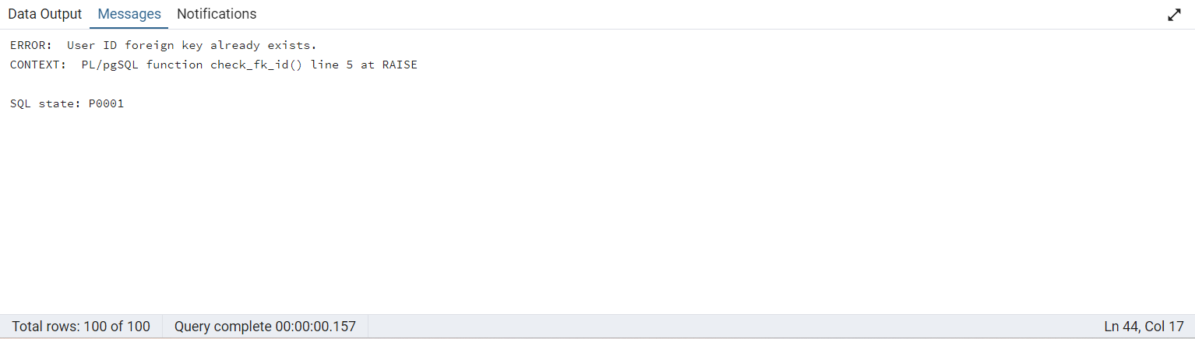
Q3. Write a SQL function that takes a product's product id and a discount percentage as inputs and returns the discounted price Of the product.
Ans)
Function:
CREATE OR REPLACE FUNCTION get_disc_price(pro_id INT, disc_per NUMERIC)
RETURNS NUMERIC
LANGUAGE plpgsql
AS $BODY$
DECLARE
og_price NUMERIC;
disc_price NUMERIC;
BEGIN
SELECT price INTO og_price
FROM "EC_DB".products
WHERE product_id = pro_id;

disc_price = og_price - (og_price * disc_per / 100);

RETURN disc_price;
END;
$BODY$;
TestCase: select get_disc_price(1,5);
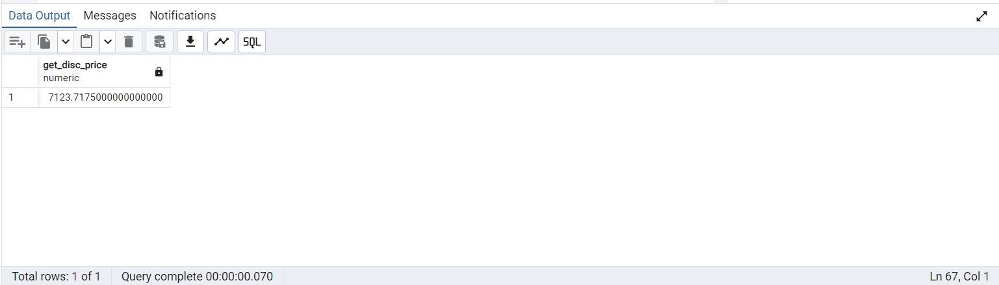
Q4. Create a stored procedure named add_order that takes the user_id, shipping_address, and a list of product_id and quantity pairs as inputs, and inserts a new order into the orders and order_details tables. The procedure should also update the stock quantity of the products.
Ans) Didn’t understand how to do it

Q5. Write a trigger that automatically decreases the stock quantity of a product in the products table when a new order is inserted into the order details table.
Ans)
Function:
CREATE OR REPLACE FUNCTION dec_stock_qty()
RETURNS TRIGGER
LANGUAGE plpgsql
AS $BODY$
BEGIN

UPDATE "EC_DB".products
SET stock_quantity = stock_quantity - NEW.quantity
WHERE product_id = NEW.product_id;
RETURN NEW;
END;
$BODY$;

Trigger:
CREATE OR REPLACE TRIGGER trigger_q5
AFTER INSERT ON "EC_DB".order_details
FOR EACH ROW
EXECUTE FUNCTION dec_stock_qty();

Test Case:
INSERT INTO "EC_DB".ORDER_DETAILS VALUES (302,100,50,10,6000)
select * from "EC_DB".order_details;
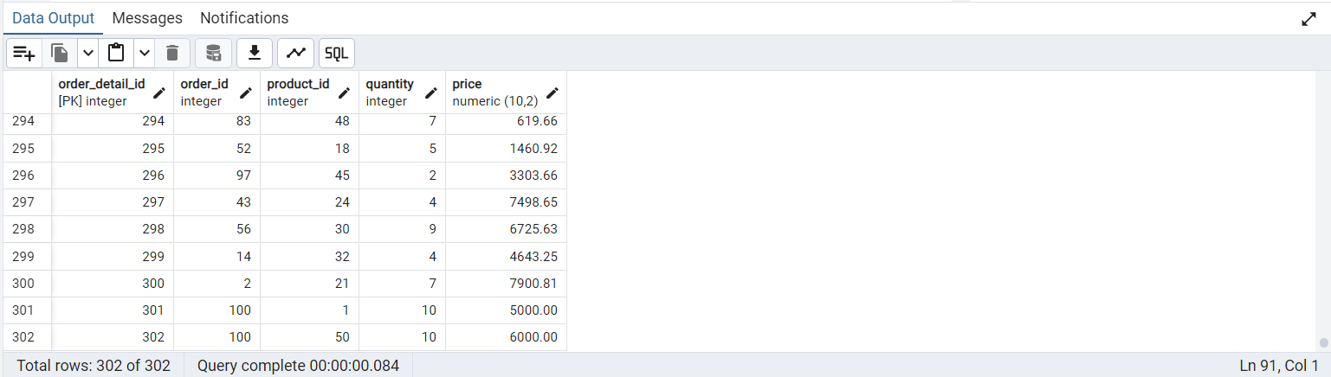
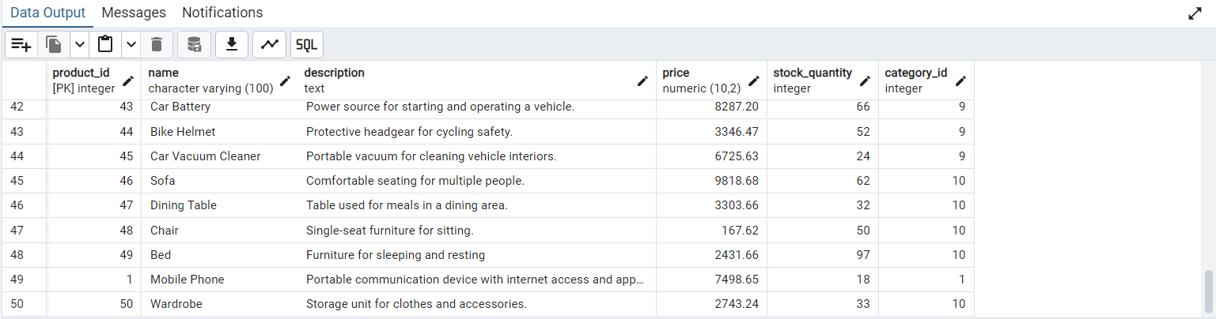
(Qantity Reduced)

